**Functional Documnet**

|  |  |
| --- | --- |
| **Application** | NGERP – Centra |
| **Service Bundle** | Sales Management |
| **Service Request** | Update Customer Confirmation |

**Description:**

In **Compiere (NGERP - Centra)** Updates the Customer Confirmation details for a Delivery Order (DO) through the "**Update Customer Confirmation**" screen. The document status changes from Completed to Draft after the update.

**Workflow Process:**

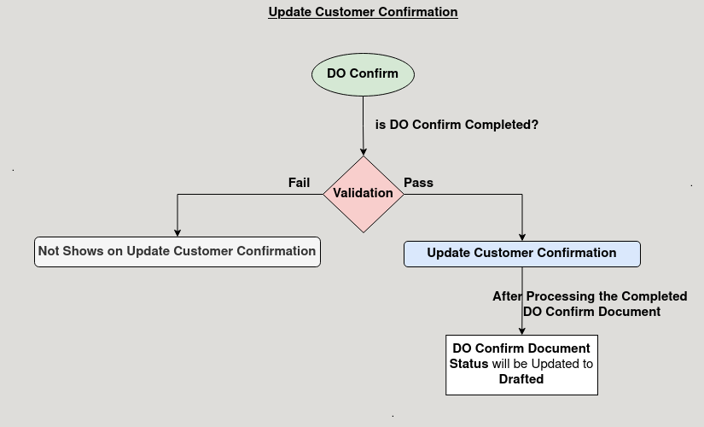

**Business Rules:**

* It is visible only in **ROW**.
* users can update **manually** the DO in the "**Update Customer Confirmation**" screen.
* The system automatically changes the document status from Completed to Draft after the update.